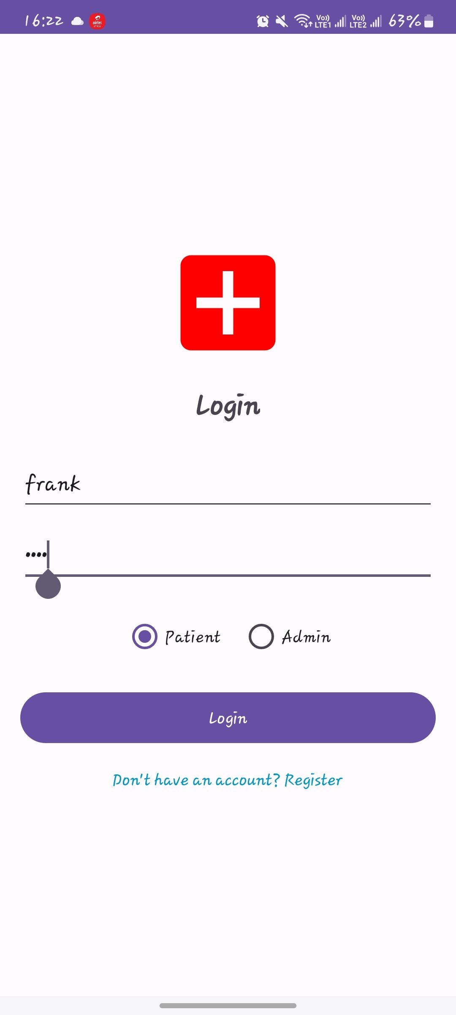
when the user enters wrong login details he/ she can't acces the app
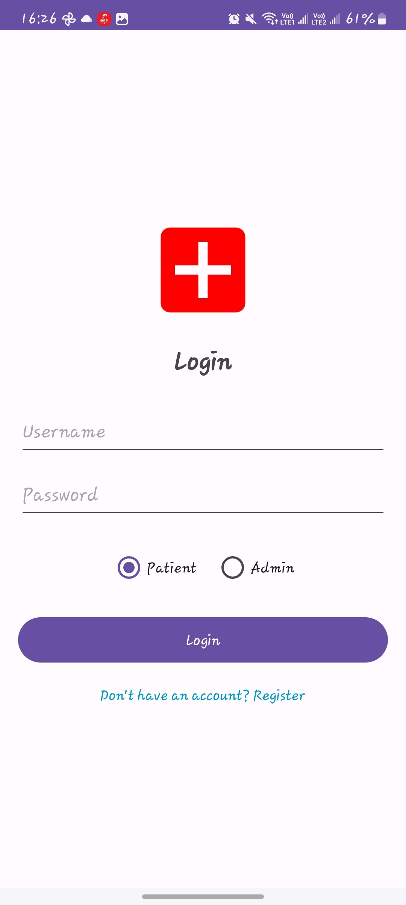

once he or she enters correct creditantial it successfully saves them
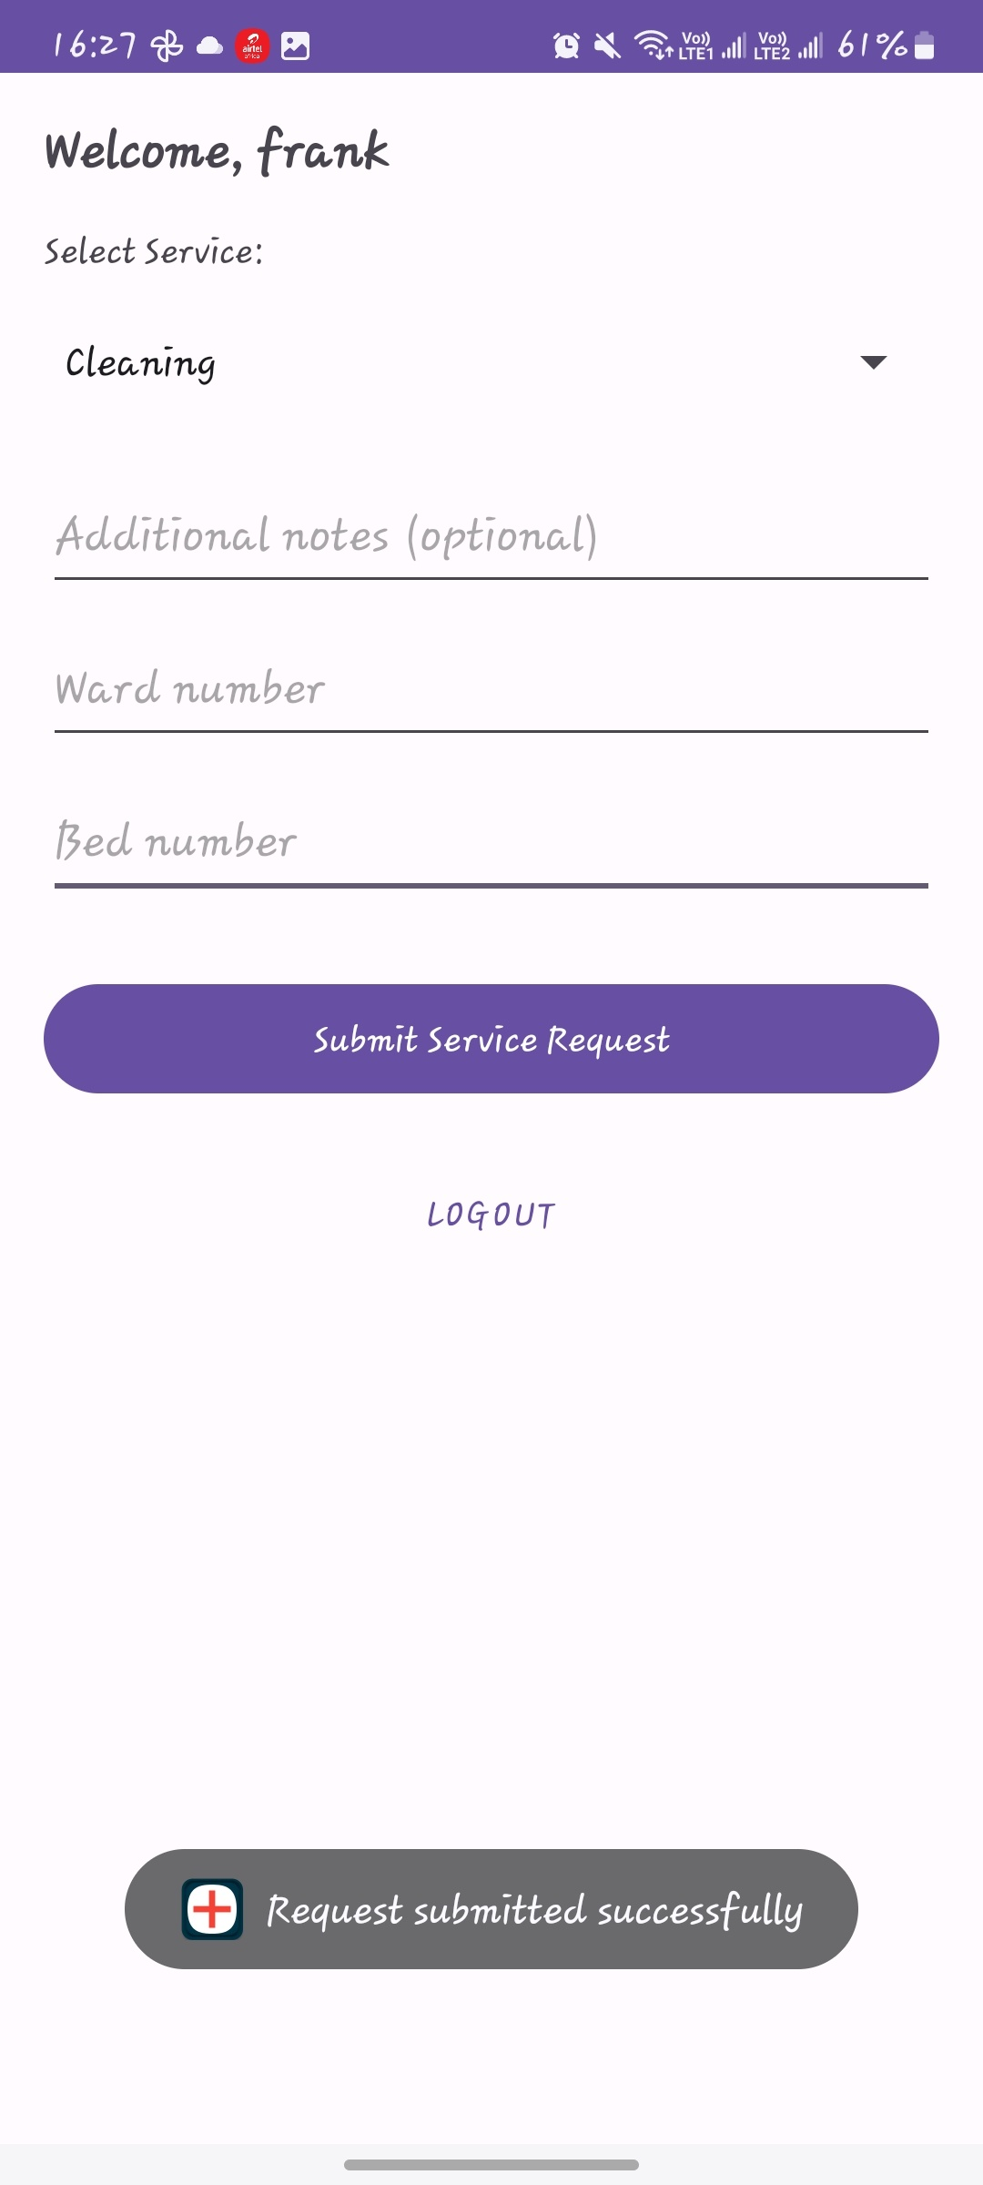

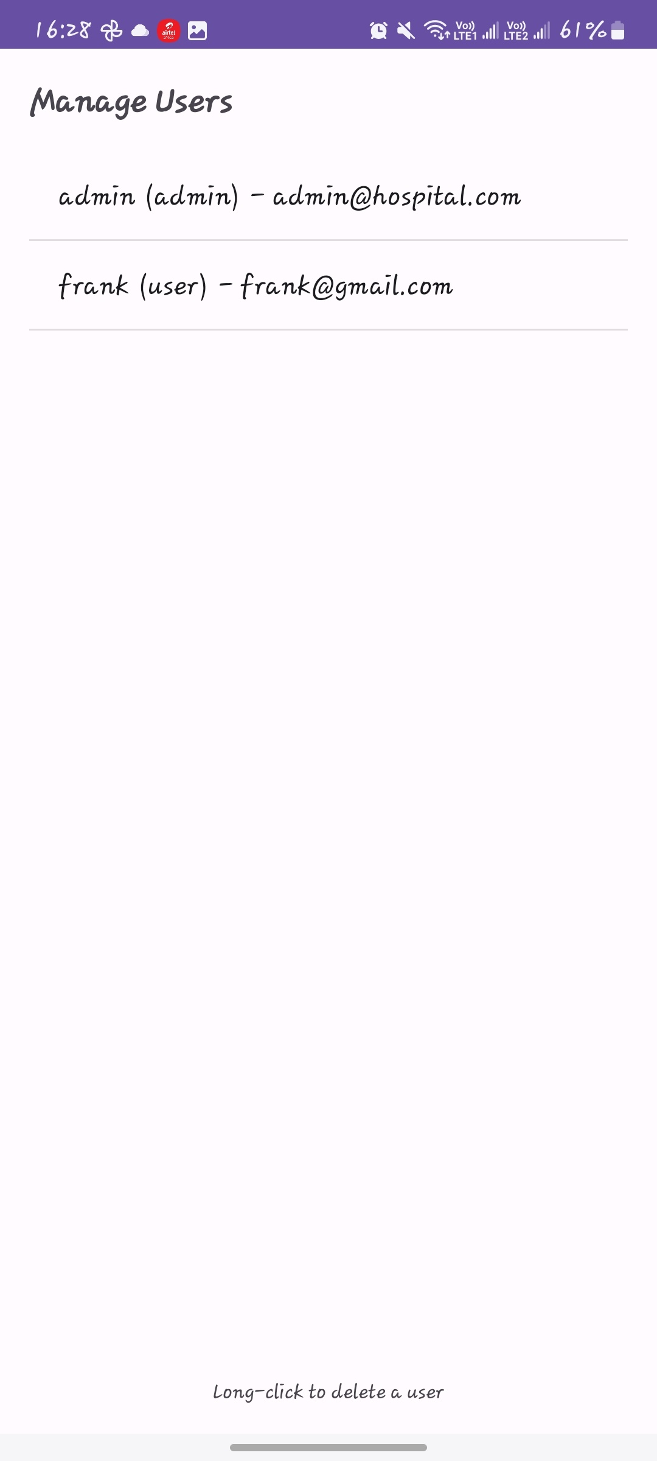
once the admin long click on a users id it will delete immediately
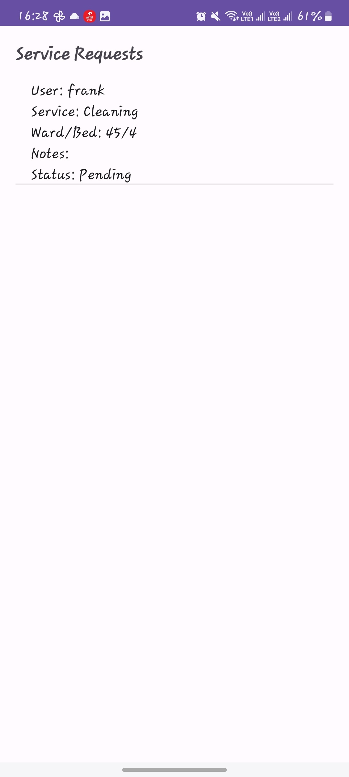

the patient must identify what service he want to be assisted with so as the admin can see
Once it is submitted it saved to a database

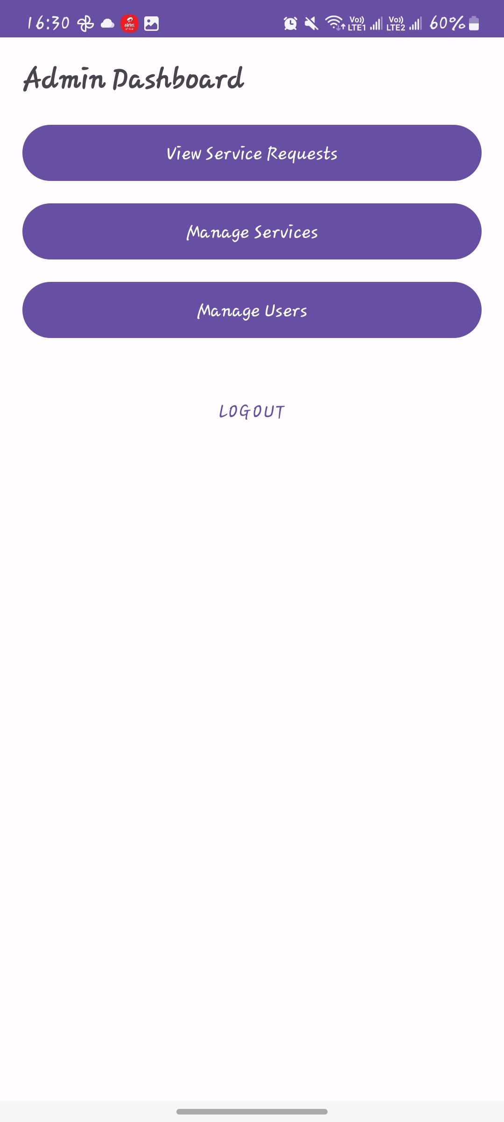
this i the admin dashboard

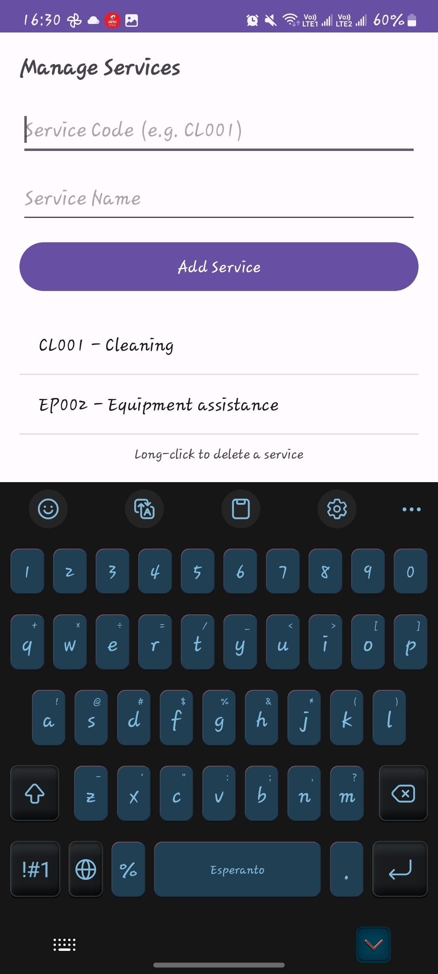
the admin has the ability to delete or add a service on the application

1. Resource/Theme Errors (Most Likely)
•
Error: Widget.MaterialComponents.Button.TextButton fails to render or crashes at runtime.
•
Cause: You are using a Material 3 theme (Theme.Material3.DayNight.NoActionBar) but referencing Material 2 styles (Widget.MaterialComponents.*).
•
Solution: Update your button styles to use Material 3 equivalents, or ensure you are using com.google.android.material.button.MaterialButton in your XML.
◦
Change: style="@style/Widget.MaterialComponents.Button.TextButton"
◦
To: style="@style/Widget.Material3.Button.TextButton"
2. Database Errors (Room)
•
Error: java.lang.IllegalStateException: Cannot access database on the main thread since it may potentially lock the UI for a long period of time.
•
Cause: You are performing database operations (like login or insertUser) on the main UI thread. I noticed this in LoginActivity.java.
•
Solution: Wrap database calls in a new Thread(() -> { ... }).start() or use AsyncTask / Coroutines. (I have already updated your LoginActivity to include these wrappers).
3. Missing Resource Errors
•
Error: Resource not found for @drawable/ic_hospital.
•
Cause: Referencing an icon in XML before the file has been created or if the filename has a typo.
•
Solution: Ensure ic_hospital.xml exists in the app/src/main/res/drawable folder. I have created this for you in the previous step.
4. Build Errors (AndroidX/Jetifier)
•
Error: Configuration contains AndroidX dependencies, but the android.useAndroidX property is not enabled.
•
Cause: Modern libraries (like Room 2.6.1) require AndroidX to be explicitly enabled in the project settings.
•
Solution: Add android.useAndroidX=true and android.enableJetifier=true to your gradle.properties file. (I have already applied this fix for you).
5. Runtime Errors (NullPointerException)
•
Error: findViewById returning null.
•
Cause: Trying to access a view ID (like rgLoginRole) in LoginActivity.java that doesn't exist in the associated XML (activity_login.xml).
•
Solution: Always ensure the ID in your Java/Kotlin code exactly matches the android:id attribute in your XML layout. I have synchronized these IDs for you in the Login and Register screens.
Proactive Improvements:
•
Hardcoded Strings: Your layouts currently use hardcoded text (e.g., android:text="Logout"). While not a crash error, it's best practice to move these to res/values/strings.xml for better maintainability and translation support.
•
Content Descriptions: Add android:contentDescription to your ImageViews to ensure your app is accessible to users with screen readers.
AndroidX Dependency Error (The "Build Blocker")
•
Likely Error: Configuration ':app:debugAnnotationProcessorClasspath' contains AndroidX dependencies, but the android.useAndroidX property is not enabled.
•
Cause: Your project was using modern libraries like Room 2.6.1 and Material 1.10.0, which require the AndroidX ecosystem to be active.
•
Solution: I updated your gradle.properties file to include android.useAndroidX=true and android.enableJetifier=true. This allows the build system to correctly process these modern libraries.
2. Layout Rendering Error (Material Theme Mismatch)
•
Likely Error: Render Problem in the Design tab for activity_admin_main.xml.
•
Cause: You were using a Material 3 theme (Theme.Material3.*) but trying to apply a Material 2 style (@style/Widget.MaterialComponents.Button.TextButton). This often results in a "failed to instantiate" error or invisible components.
•
Solution: I updated the style to @style/Widget.Material3.Button.TextButton and recommended using com.google.android.material.button.MaterialButton to ensure the Layout Editor can properly render the button with the correct theme attributes.
3. Database "Main Thread" Crash
•
Likely Error: java.lang.IllegalStateException: Cannot access database on the main thread...
•
Cause: Android prevents database operations on the UI thread to keep the app responsive. Your initial LoginActivity was querying the database directly in the onClick listener.
•
Solution: I wrapped the database operations in new Thread(() -> { ... }).start() and used runOnUiThread to handle UI updates (like Toasts or Intent switching) once the background task finished.
4. Role Conflict Error
•
Likely Error: A user registered as a "Patient" could accidentally log in and see the "Admin" dashboard if the app didn't verify the intended role.
•
Cause: The original login logic only checked if the username/password existed, not if the user's role matched the login intent.
•
Solution: I added a RadioGroup to both Login and Registration screens.
◦
At Registration: The user explicitly chooses "Admin" or "Patient."
◦
At Login: The app now checks: if (!user.role.equals(selectedRole)). If they don't match, it shows: "Incorrect role selected for this user."
5. Generic App Identity (The Icon Issue)
•
Likely Error: The app appeared on the device with the default "Green Android Robot" icon.
•
Cause: The project was using the template launcher icons provided by Android Studio.
•
Solution: I created a custom ic_hospital.xml vector and updated the Adaptive Icon layers (ic_launcher_foreground and ic_launcher_background) to a red-and-white medical cross design, giving your app a distinct hospital identity.
6. Accessibility and Lint Warnings
•
Likely Error: Yellow warnings in the XML editor for "Hardcoded Strings" and "Missing Content Description."
•
Solution: I added android:contentDescription="App Logo" to your images and identified the hardcoded strings (like "Admin Dashboard") that should eventually be moved to strings.xml to support multiple languages and better maintenance.

